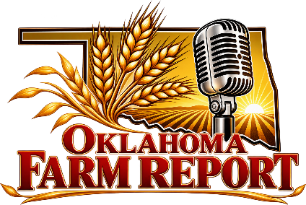
DIGITAL
ADVERTISING
ONLINE AT
OKLAHOMAFARMREPORT.COM

Available Website Zone | Banner Size | Exclusive Monthly | Rotation Monthly
Default Page Ad - 540x120 | Custom (540x120) | $100 | $75
Large Footer Ad | Custom (970x250) | $300 | $50
Mobile Ad Unit | Custom (320x50) | $75 | $50
Right Ad - Top Daily Email Sponsors | IAB Medium Rectangle (300 x 250) | $125 | $100
Right Ad 1 - 250x300 | Custom (250x300) | $100 | $75
Right Ad 2 - 300x250 | IAB Medium Rectangle  (300x250) | $100 | $75
Right Ad 3 - 300x250 | IAB Medium Rectangle  (300x250) | $100 | $75

2401 Exchange Avenue, Suite F, Oklahoma City, OK 73108
Phone: 530-345-0021
KMXI.COM

